USER’S MANUAL
- General Description
DDS238-2 ZN/S type multi-function energy meter is designed to measure single phase two wire AC active energy and variable parameter. All of its functions comply with the relative technical requirement for class 1 single phase watt hour meter in IEC62053-21 and its data communication rules obey the requirement of DL/T645 or MODBUS-RTU. It is a long life meter with the advantage of high stability , high over load capability , low power loss and small volume .
The meter should be installed in suitable environment with ambient temperature range between -25℃～+55℃,the relative humidity less than 75% and temperature limits between and-40℃～+70℃.
The meter is manufactured complying with international standard IEC62052-11 on “Electricity metering equipment (AC) General requirements tests and test conditions” and IEC62053-21 on “Static meters for active energy (classes 1 and 2)”.

2.Specification and Technical Parameters
2.1Specification
Meter type | DDS238-2 ZN/S
Rate frequency | 50 or 60 Hz
Rated current | 5(65)A 10(100)A
Rate voltage | 120V / 220V / 230V /240V
Normal voltage range | 90%Un～110%Un
Limits voltage range | 70%Un～120%Un
Accuracy | Class 1
Pulse constant | See meter
RS485 port | MODBUS-RTU protocol, 1200～9600bps,None parity, default 9600bps

2.2 Technical Parameters
2.2.1 Basic tolerance
Load current(A) | Power factor  (CosΦ) | Basic error(%)
Load current(A) | Power factor  (CosΦ) | 1.0 class | 2.0 class
0.05Ib | 1.0 | +1.5 | +2.5
0.1Ib—Imax | 1.0 | +1.0 | +2.0
0.1Ib | 0.5(lag) | +1.5 | +2.5
0.1Ib | 0.8(advanced) | +1.5
02Ib—Imax | 0.5(lag) | +1.0 | +2.0
02Ib—Imax | 0.8(advanced) | +1.0

2.2.2 Self-consumption
Current circuit is less than 1.5VA
Voltage circuit is less than 1W/5VA
2.2.3 Starting current
Under the rated voltage , rated frequency and COSΦ=1 , the meter shall start and continue to register on application of 0.2% In (if CT is used) or 0.4% Ib .
2.2.4 Anti-creeping
The meter has anti-creeping logical circuit. When 115%Un is connected to the meter and current circuit is cut , the meter shall not create more than one pulse in a stipulated time
2.2.5 Average-life
The meter can be used for at least 10 years in normal operation specified in this manual
2.2.6 LCD: 5+1 (99999.9 kWh)
3.Basic Features
3.1 Measuring positive & negative active energy with negative energy accumulated into positive energy, LCD display with backlight .
3.2 The meter also display three phase real voltage , real current , real active power , real power factor , real frequency
3.3 Pulse LED indicates working of meter，Pulse output with optical coupling isolation 18~27V 27mA .
3.4 RS485 communication port
3.5 Measuring active energy without calibration under long term operation
3.6 display step by step with button
4.Working principles
Single phase voltage and current are sampled from respective sampling circuit and transformed into suitable signal, which is carried into integrated circuit , then the meter output pulse signal in positive appropriation to measured power to drive step-motor counter or LCD counter to realize energy measurement. The meter has energy pulse output for testing with pulse width of 80+20ms
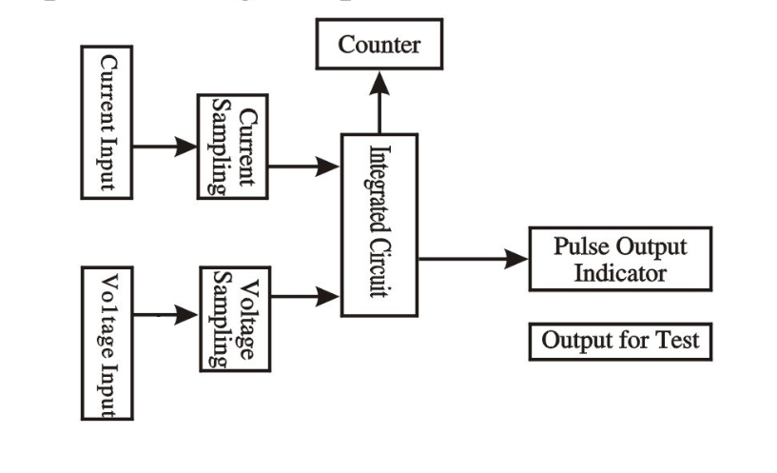
Diagram for Working Principles

5. Structure
The meter consists of meter base , meter cover , terminal base , terminal cover . there are lead seal on meter cover and terminal cover . A special screw is used to fix the terminal cover on which a lead seal can be installed
6. Usage
6.1 Connection diagram
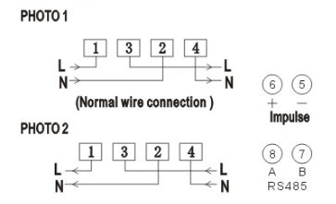
Note: If reverse wire connection as photo 2 , the total energy still can measure.

6.2 Installation
The meter can be installed on a 35 mm DIN rail
6.2.1 The meter can not installed and used until it is checked goods and sealed before delivery
6.2.2 The meter should be install in the water proof box indoor or outdoor . the meter’s box should be fixed on strong and flame-resistant wall with a recommended height of about 1.8 m , where there is no corrosive gas around .

6.2.3 The meter should be install fully in accordance with connection diagram on the terminal cover, it is better to use copper as the leading wire for connection. All screws should be tightened.
6.2.4 Diagram for installation dimension
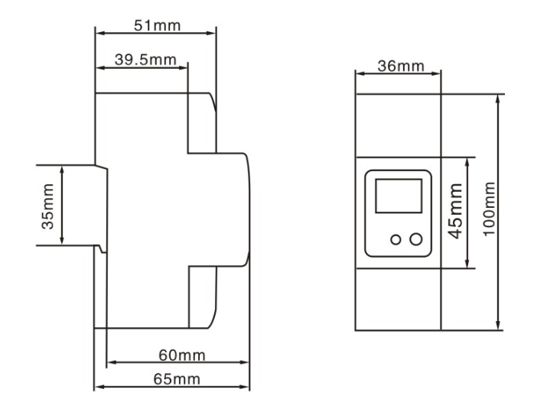

7. Transportation and Storage
7.1 Heavy impact should be burdened to the products while transportation and unpacking.
7.2 The products should be stored in the original package and kept in place with temperature between -40℃～+70℃,the relative humidity less than 75% and no corrosive gas around .
7.3 In storehouse , the meter should be placed on the shelf when kept in stock , there should not be more than 7 cartons piled up in vertical. Single-packed meters can not be piled up with more than 5 meters in vertical.

8. Warranty period
Within 24 months from the day of selling and provided that users operate correctly according to the requirement of the user’s manual , if the meter doesn’t reach its technical specification. It can be repaired or replaced in free f charge by the manufacturer .

9. Frame format
  - Read command（function code 03）
Send frame
Meter ID | Function code | Register address | Data number | Check code (CRC)
1byte | 1byte | 2byte | 2byte | 2byte

Receive frame
Meter ID | Function code | Data length n | Data area | Check code (CRC)
1byte | 1byte | 1byte | n byte | 2byte

  - Write command（function code 10）
Send frame
Meter ID | Function code | Register address | Data number | Data length n | Data area | Check code (CRC)
1byte | 1byte | 2byte | 2byte | 1byte | n byte | 2byte

Receive frame
Meter ID | Function code | Register address | Data number | Check code (CRC)
1byte | 1byte | 2byte | 2byte | 2byte

  - Energy meter register address
Register address | Data number | Data item | Data format | Data unit
0x0000 | 2 | Total kWh | XXXXXX．XX | kWh
0x0001
0x0008 | 2 | Export kWh | XXXXXX．XX | kWh
0x0009
0x000A | 2 | Import kWh | XXXXXX．XX | kWh
0x000B
0x000C | 1 | Voltage | XXX．X | V
0x000D | 1 | Current | XX．XX | A
0x000E | 1 | Active power | XXX．XXX | kW
0x0010 | 1 | Power factor | X．XXX
0x0011 | 1 | frequency | XX．XX | Hz
0x0015 | 1 | ID + baud rate | First byte is ID号，the second byte is baud rate，01~04 is means Respectively 9600、4800、2400、1200、
Note 1: one register address is store 2 byte data ,so the data length read as 4 byte when data number is 2 .
Note 2:：you can use ID ID(0x00) to broadcast and got data when you do not know the meter ID. But this ways is only for 1 pcs meter to connection on RS485 wire
10. Display item
 | INFORMATION | LCD DISPLAY
01 | Meter ID | ID 001 | ★
02 | Real voltage V | U 000.0 | ★
03 | Real current A | A 00.00 | ★
04 | Real power W | P 0.0 | ★
05 | Power factor COSФ | PF 0.00 | ★
06 | Real frequency Hz | F 00.00 | ★
07 | Total energy kWh | T00 00000.0 | ★
08 | Positive kWh | T00-00000 | ☆
09 | Reverse kWh | T00-00000 | ☆
10 | Reset energy | EP000000 | ☆

Note: ★Standard function ,☆special order function (It will reset energy to zero, after you pull the button last 10s,if you have order reset function)

 | INFORMATION | LCD DISPLAY
01 | Impulse constant imp/kWh | C 0000
02 | Total energy kWh | T00 00000.0
03 | Import energy kWh | T01 00000
04 | Export energy kWh | T02 -00000
05 | Reset energy kWh | EP 00000
06 | Real Current A | I 000.00
07 | Real voltage V | U 000.00
08 | Active power W | P 00000.0
09 | Reactive power var | q 00000.0
10 | POWER FACTOR COSΦ | PF 0.00
11 | Real frequency Hz | F 0.00
12 | MODBUS-RUT ID | ID 000
13 | DL/T645 high 6 digit ID | H 00000
14 | DL/645 low 6 digit ID | L 00000
15 | Baudrate | B 0000

